

**CSE463**

**Computer Vision: Fundamentals and Applications**

**Lecture 3**

**Light and Binocular Vision**

### **Biological Vision**

Biological vision refers to the mechanisms through which living organisms, particularly humans, perceive and interpret visual information from their surroundings. The study of biological vision provides insights into how the human visual system functions and often inspires advancements in computer vision and image processing.

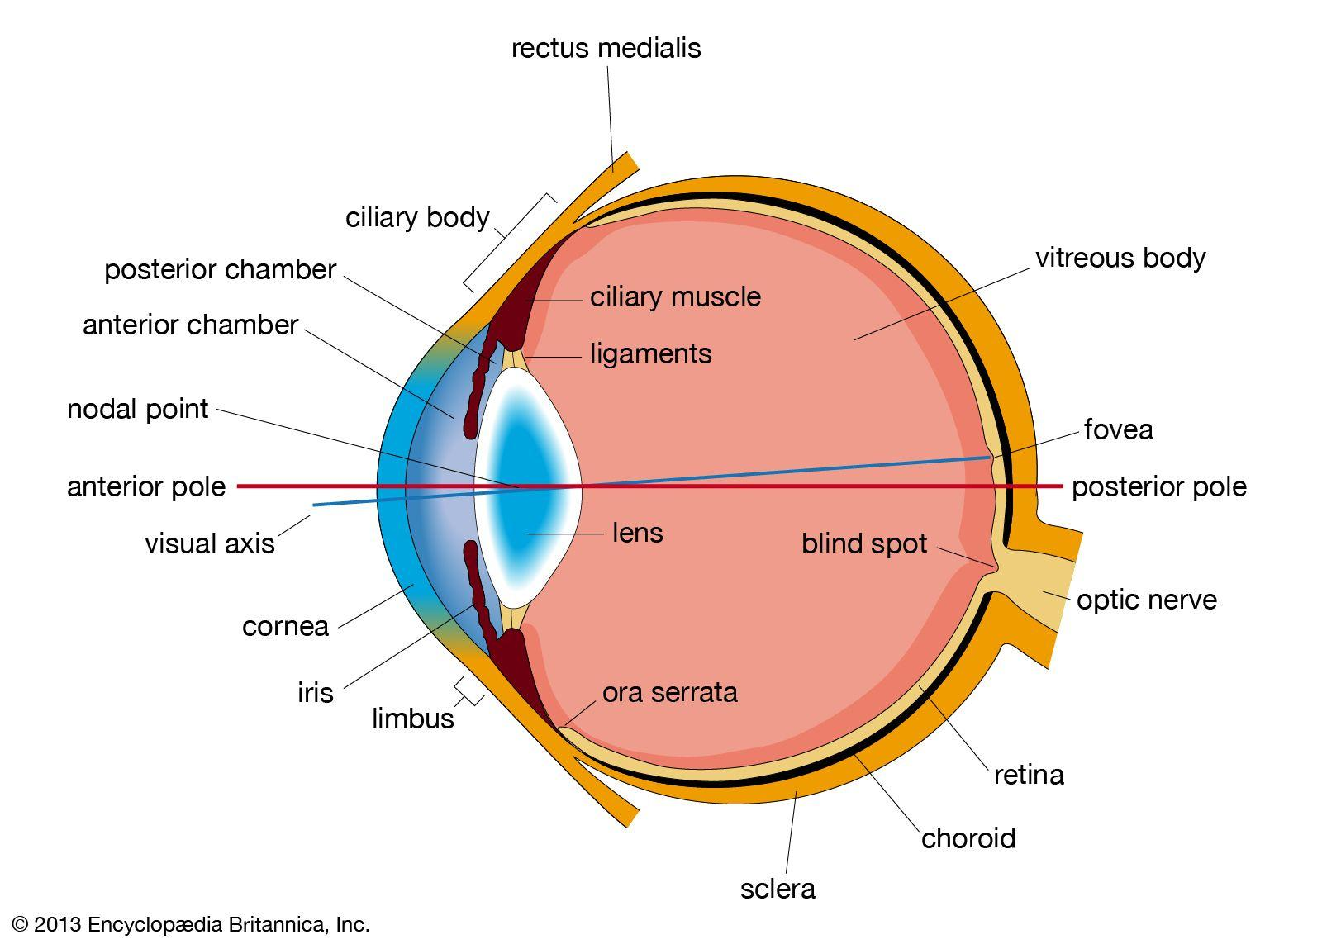

#### **Key Components of the Human Visual System**

1. **Eye Structure:**
   * **Cornea**: The transparent outer layer that focuses light onto the retina.
   * **Lens**: Fine-tunes the focus of light onto the retina for near and far objects (accommodation).
   * **Retina**: A light-sensitive layer at the back of the eye that contains photoreceptors.
   * **Photoreceptors**:
     + **Rods**: Responsible for vision in low-light (scotopic) conditions; sensitive to intensity but not color.
     + **Cones**: Active in bright-light (photopic) conditions; responsible for color vision (red, green, and blue cones).
   * **Optic Nerve**: Transmits visual information from the retina to the brain.
2. **Visual Processing in the Brain:**
   * **Primary Visual Cortex (V1)**: Processes basic visual features like edges, orientation, and motion.
   * **Higher Visual Areas**: Combine features to recognize shapes, objects, and scenes.

#### **The Visual Pathway**

#### 

1. **Light Detection:**
   * Light enters through the pupil, is focused by the cornea and lens, and forms an image on the retina.
   * Photoreceptors in the retina convert light into electrical signals.
2. **Signal Transmission:**
   * The signals pass through retinal ganglion cells and are transmitted to the brain via the optic nerve.
3. **Neural Processing:**
   * The brain interprets these signals to detect patterns, depth, motion, and colors.

#### **Visible Light**

Visible light is a part of the electromagnetic spectrum that the human eye can detect, typically ranging from wavelengths of approximately 400 to 700 nanometers. Each wavelength corresponds to a specific color that humans perceive, from violet (shorter wavelengths) to red (longer wavelengths). Cameras and imaging devices capture this range of light to create color images, which are then processed and represented in different color spaces.

#### **Color Image**

A color image represents visible light using combinations of primary colors. Most digital color images are stored in three separate channels corresponding to red, green, and blue light intensities. By combining these three channels, we can produce a wide range of colors that closely match human color perception.

#### **Color Spaces**

A color space is a way of representing colors in a structured format, allowing images to be processed and analyzed in various applications like object detection, image compression, and enhancement. Each color space has unique properties and is suitable for different tasks. Some of the most common color spaces include **RGB**, **HSV**, **YCbCr**, and **L*a*b\***.

### **RGB Color Space**

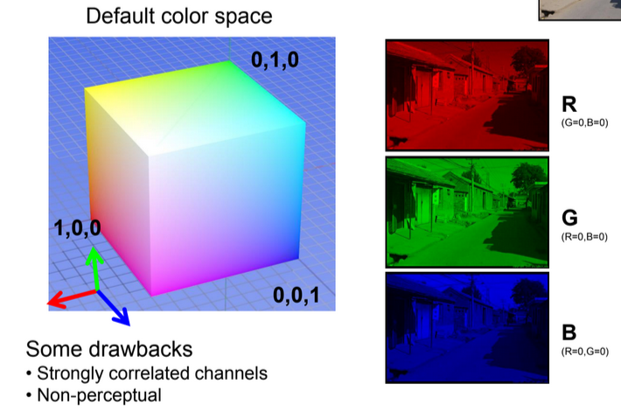

RGB is the most common color space, representing colors by their red, green, and blue (RGB) components. Each color is defined by a combination of these three values, ranging from 0 to 1 (normalized) or 0 to 255 in 8-bit representation.

* **Primary Colors**:
  + **Red (1,0,0)**: Maximum red, no green, no blue.
  + **Green (0,1,0)**: Maximum green, no red, no blue.
  + **Blue (0,0,1)**: Maximum blue, no red, no green.

RGB is often visualized as a **color cube** where each axis corresponds to one of the RGB values. The color at any point inside the cube is a mix of these three colors.

#### **Drawbacks of RGB:**

* **Channel Correlation**: The RGB channels are highly correlated, meaning changes in one channel often affect perceived brightness and color, which can complicate color-based tasks like segmentation.
* **Non-perceptual**: RGB is not aligned with human color perception, making it difficult to manipulate colors in a way that corresponds to how we intuitively see and perceive them.

Despite these drawbacks, RGB remains the **default color space** for most imaging devices and digital displays due to its straightforward representation.

### **HSV Color Space**

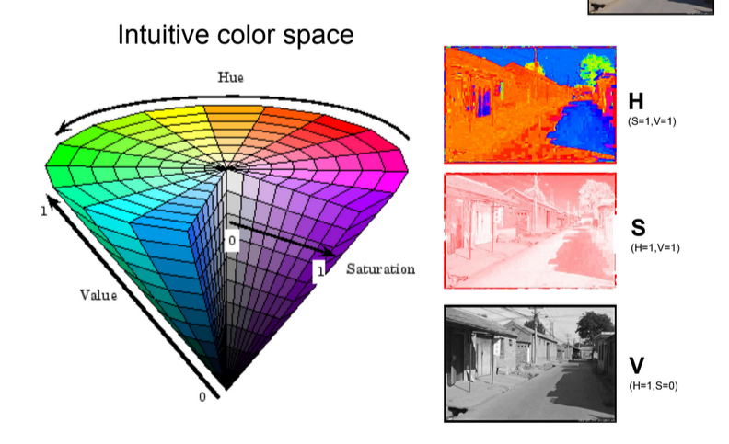

HSV (Hue, Saturation, Value) is an **intuitive color space** that aligns more closely with how humans perceive colors. It is useful for color-based image processing and editing tasks.

* **Hue (H)**: Represents the color type, ranging from 0 to 1. Hue is an angular value, often visualized on a color wheel.
* **Saturation (S)**: Represents the intensity of the color, with 0 being grayscale and 1 being fully saturated color.
* **Value (V)**: Represents the brightness, with 0 being black and 1 being full brightness.

#### **Primary HSV Colors:**

* **H (S=1, V=1)**: Represents the pure color tone at maximum saturation and brightness.
* **S (H=1, V=1)**: Maximum color intensity.
* **V (H=1, S=0)**: Represents grayscale brightness.

The HSV color space is ideal for color-based segmentation, filtering, and detection, as colors can be manipulated independently of brightness and saturation.

### **YCbCr Color Space**

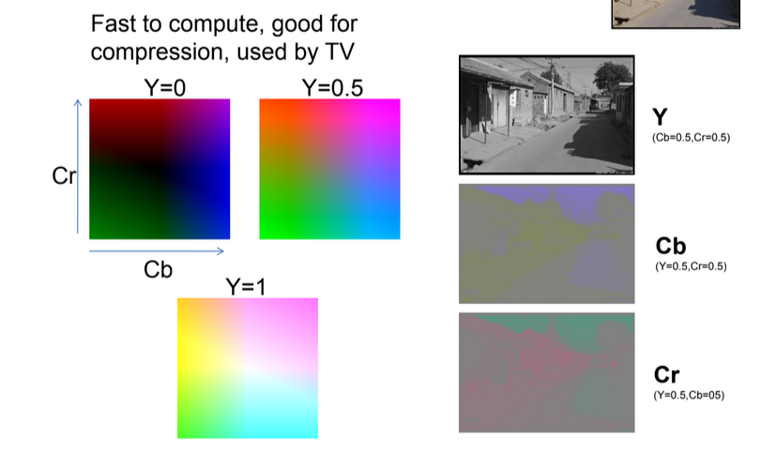

YCbCr is widely used in image and video compression due to its efficient representation of color and brightness. It separates **luminance** (Y) from **chrominance** (Cb and Cr) components.

* **Y**: Represents the luma or brightness component.
* **Cb**: Blue-difference chroma component.
* **Cr**: Red-difference chroma component.

In digital imaging, the **Y channel** handles most of the intensity information, while **Cb and Cr channels** represent color differences. This separation allows for efficient **compression** by reducing the resolution or bit-depth of the chrominance channels without significantly affecting perceived image quality.

#### **Primary YCbCr Values:**

* **Y (Cb=0.5, Cr=0.5)**: Luma component at mid-level chrominance.
* **Cb (Y=0.5, Cr=0.5)**: Blue-difference component.
* **Cr (Y=0.5, Cb=0.5)**: Red-difference component.

YCbCr is widely used in **television** and **digital video** standards due to its fast computation and compatibility with compression algorithms.

### **L*a*b* Color Space**

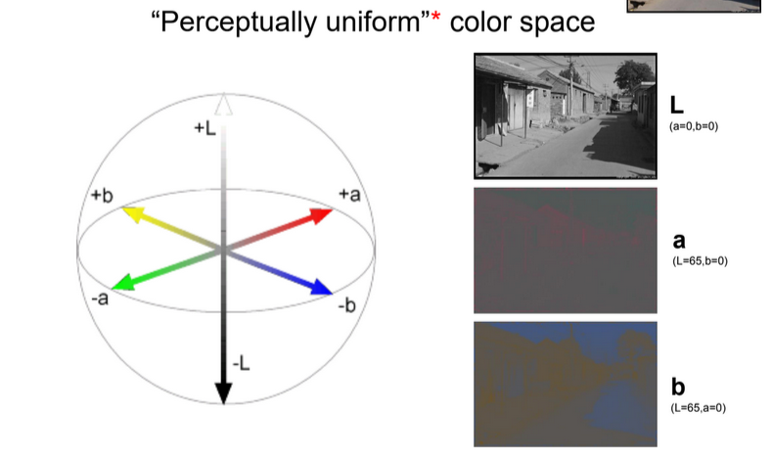

The L*a*b* color space (also known as CIELAB) is designed to be **perceptually uniform**. It is based on human vision, with L* representing **lightness** and a*, b* representing **color-opponent dimensions** (green–red and blue-yellow).

* **L\***: Lightness, ranging from 0 (black) to 100 (white).
* **a\***: Green–red component, where positive values indicate red and negative values indicate green.
* **b\***: Blue–yellow component, where positive values indicate yellow and negative values indicate blue.

L*a*b* color space is used in applications where color accuracy and perceptual uniformity are essential, such as color correction, editing, and comparison.

| **Color Space** | **Properties** | **Common Uses** |
| --- | --- | --- |
| RGB | Device-friendly, non-perceptual | Display, general image storage |
| HSV | Intuitive, perceptual attributes | Color detection, segmentation |
| YCbCr | Efficient for compression | Video, TV broadcasting |
| L*a*b* | Perceptually uniform, accurate | Color correction, analysis |

### 

### Exercises

1. What is visible light, and how does it relate to the concept of color in digital imaging?
2. Describe the RGB color space. Why is it the default color space in most digital devices, and what are its drawbacks?
3. Explain how the HSV color space differs from RGB. Why is HSV considered more intuitive for certain color-based applications?
4. What are the primary components of the YCbCr color space, and why is it commonly used in video compression?
5. Describe the purpose of each component in the L*a*b* color space and explain why it’s useful for tasks requiring perceptual uniformity.
6. How does separating luma (Y) from chrominance (Cb, Cr) in YCbCr enable more efficient compression?
7. What kind of tasks are best suited for the HSV color space, and why? Provide an example of an application where HSV would be more useful than RGB.
8. What does it mean for a color space to be 'perceptually uniform,' and which color space is designed with this property in mind?
9. If you were processing an image to adjust its brightness independently of color, which color space might offer the most straightforward approach?
10. Explain how the different axes in the RGB color cube represent color combinations. What color would you get if R=1, G=0, and B=0?

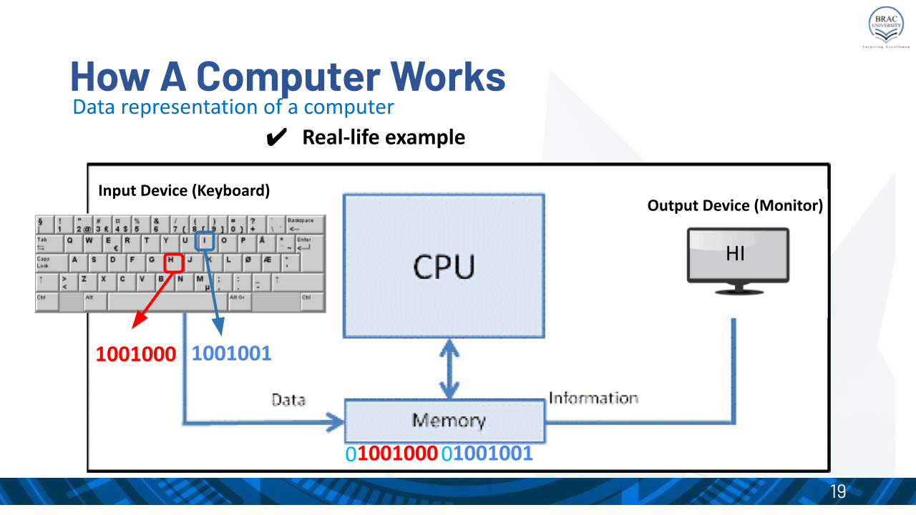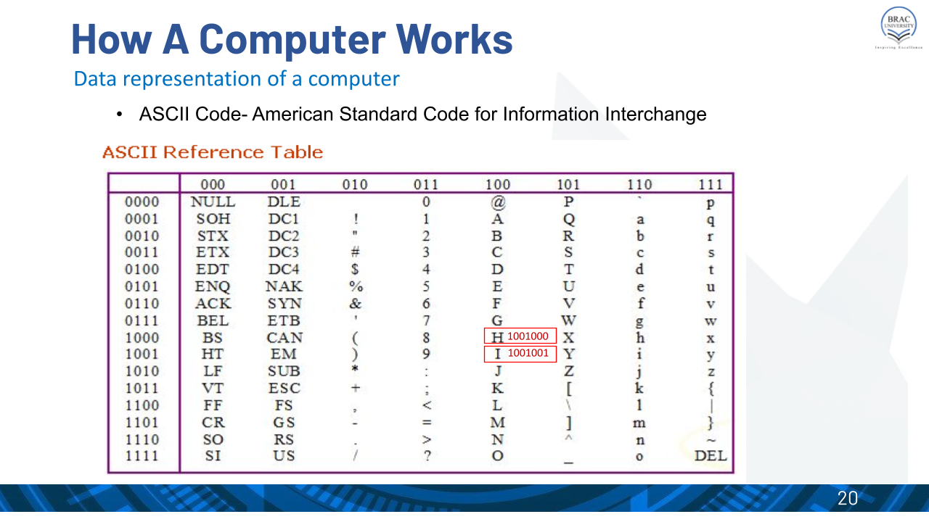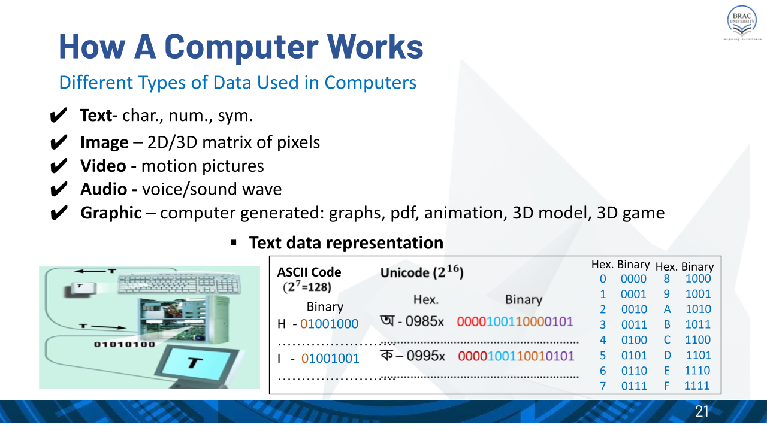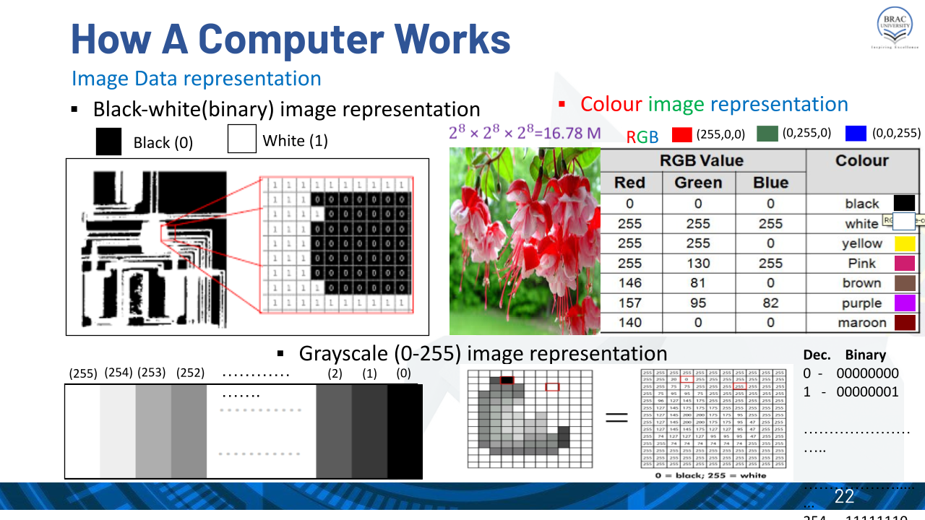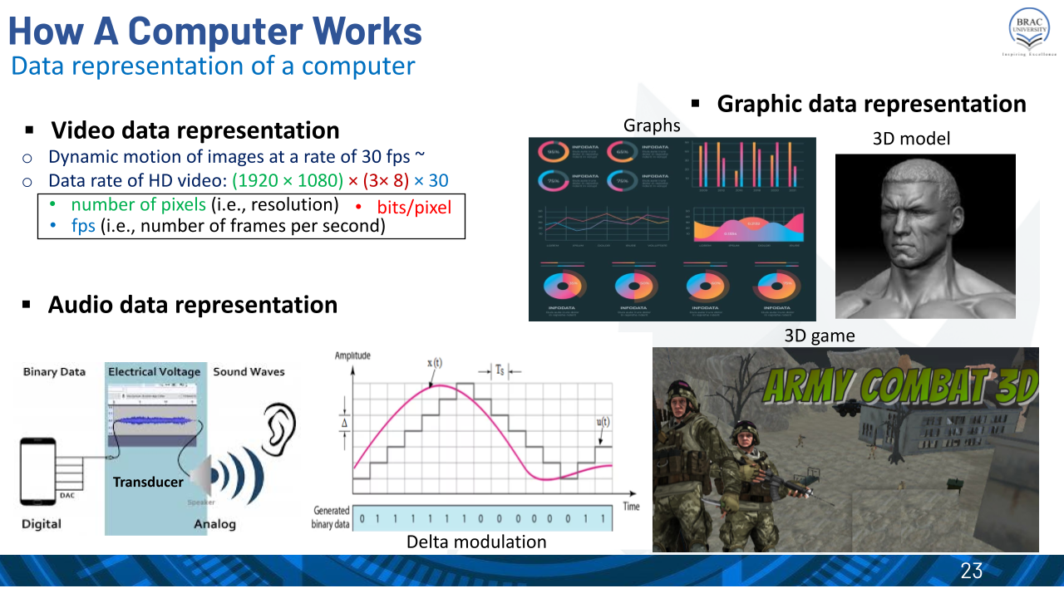

**Problem 1:** Calculate the number of bits to represent a 2 minutes of video comprises of image frames with a resolution of 1920*1080 and a frame rate of 30 fps:

i) Grey-scale video

ii) color video

iii) black & white video